Bucket List

Create an application which allows users to add/update their personal bucket list item and allow other users to have the same bucket list item by tagging that specific user. Users can also see other users' bucket lists.

Use Angular and use Express MVC as the backend. Make sure that you also integrate and save the data to MongoDB.

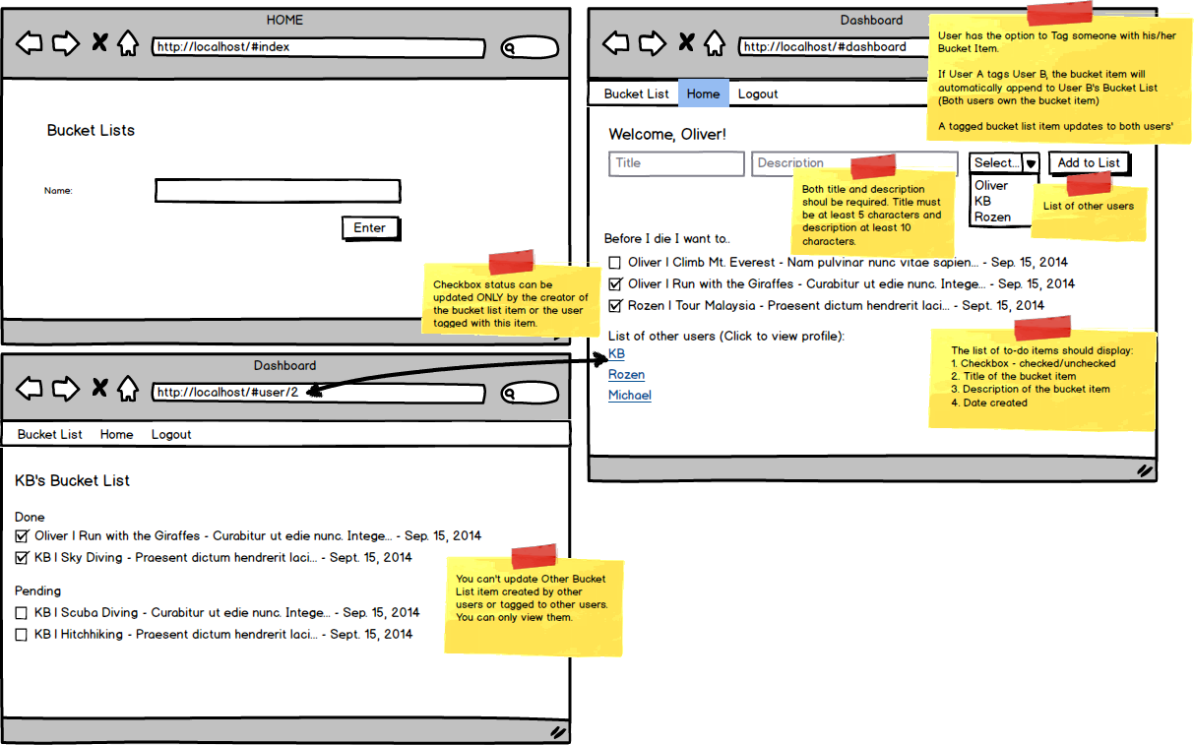

Required Features:

* Login and logout
* Dashboard displays the logged user's created bucket list items and the bucket list he was tagged with by other users.
* Bucket list item format: <creator of the bucket list> | <title> | <description> | <date created>
* Ability to add a bucket list item. Newly added bucket list item should only appear on the bucket list (profile) of the person who created the item and on the user(s) the said item is being tagged to.
* Tagging of other users. The bucket list item being tagged to the user will be included on the tagged user's bucket list.
* Update of bucket list item status (checked or unchecked) ONLY by the user who created the item or the user who was tagged with the item. Upon update, tagged users should also see a new status.
* Ability to see other users' profile with their own bucket list and bucket list items he/she is tagged with.
* You must be able to deploy your work to Amazon EC2 and provide the IP address or subdomain/domain name to where your work has been deployed. Please note that Heroku deployment is not honored.

Submission Requirement: Your code, a text file with the IP address or subdomain/domain name for the deployed work and short video demo link.

Note:

* The wireframe is available for download [here](http://s3.amazonaws.com/General_V88/boomyeah/company_209/chapter_4217/handouts/chapter4217_7897_a-bucketlist.png).
* Create a 2-3 video showing what you have built. On the video, show the functionality of the page you have built at localhost (not what was deployed). You may download a trial version of Jing, Snag-it or QuickTime for video creation. You may save it in Dropbox public folder and copy the public link.
* To prevent other students from copying your work, please make sure your video demo is set to unlisted or with a password, and code is not saved on GitHub.
* To minimize score deduction, please make sure you upload the complete requirements (database file, video demo).
* If you are having trouble uploading files on the Exam App, please DO NOT unlock another exam. Please email the file to remote-instructors@codingdojo.com and CC your instructor.

Privacy Policy